- Start the Terminal program from the top menu bar (Applications -> Accessories -> Terminal).
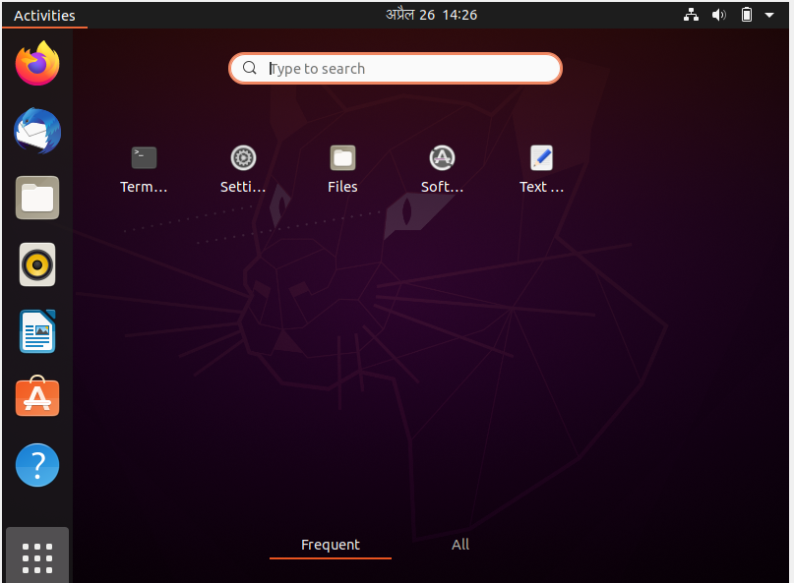

- Use commands cd, cd .. , cd / to navigate through the directories. Create the directory HCK in the desktop.
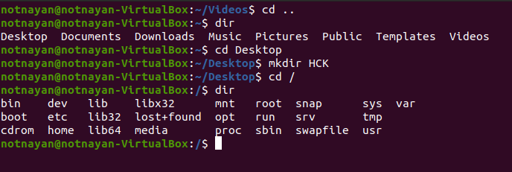

- Write the command to print current working directory. List the files and directories in the current working directories. Insert the image of your terminal here.
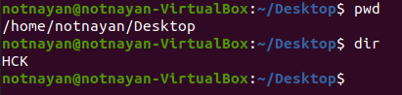

- Create New.txt file containing text “Herald College Kathmandu”, in the HCK directory.
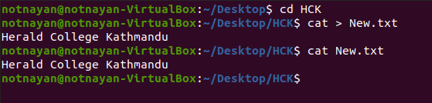

- Delete New.txt file from HCK directory.
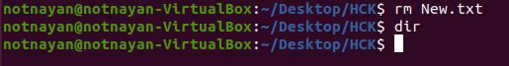

- Remove directory HCK form the Desktop.
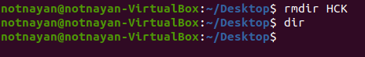

- Create directory Kathmandu in the desktop containing file Swyambhu.txt,
Rename Swayambhu.txt as Barahi.txt
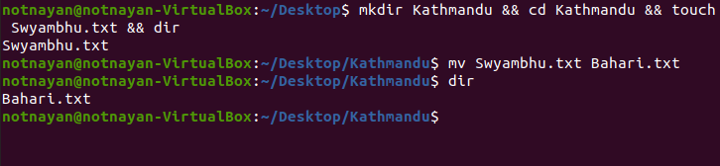

- Create Directory Pokhara in the Desktop and move Bahari.txt of directory
Kathmandu in directory Pokhara.
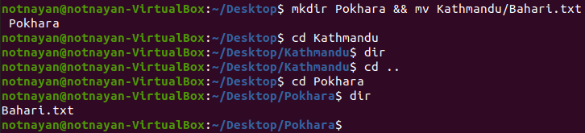

- What is the command to list all the invisible files and to display the directories in detail?
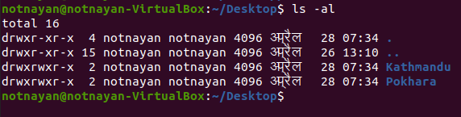

- What is the command to make a directory named IPHONE and IPAD and remove the directory named IPAD?
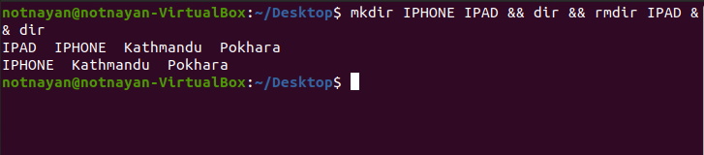

- Create file hck.txt containing text “Herald College Kathmandu” and another file hck1.txt containing text “Sanugaucharan, Naxal” concatenate these two files and give name HCK.txt.
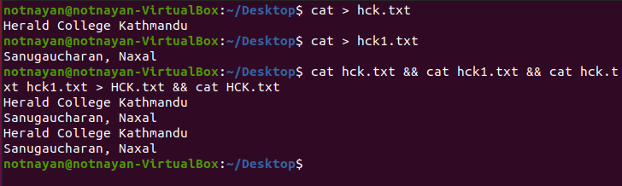

- Create filename1.txt and filename2.txt in the Desktop and create compressed file new.zip which contains filename1.txt and filename2.txt.
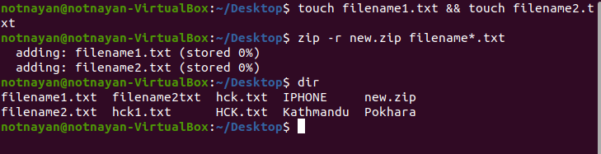

- Check the permissions for User, group and world for new.zip and set read permission for user, read and write permission for group and read write and execute permission for world.
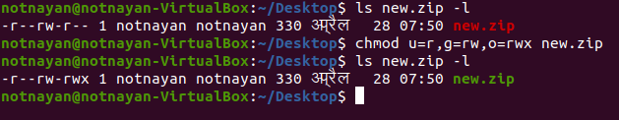

- Write the command to check your last 10 commands.
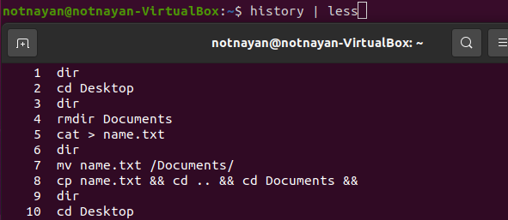

- Write the command to check current user.
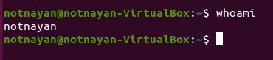

- Write the command to add user having user name newuser and switch to newuser.
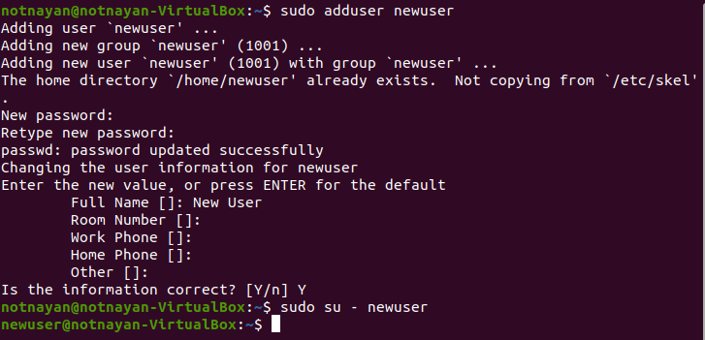

- Create the following directories in and paste your result here.
